* **EDUTAINERS**

**Series – I Specialist of Sciences Date: 05/02/18**

**BIO Ch # 4(1st Half) T7 1st Year Time: 75min Marks: 40**

**Name: _________________________ Objective**

**Q1: Choose the Correct Answer** **(10 x 1 = 10)**

|  |  |  |  |  |  |  |  |  |
| --- | --- | --- | --- | --- | --- | --- | --- | --- |
| **1** | **The resolution of human eye is:** | | | | | | | |
| **a.** | | 0.01mm | **b.** | 0.1mm | **c.** | 1.0mm | **d.** | 10mm |
| **2** | **Cell theory is not applicable to:** | | | | | | | |
| **a.** | | Cyanobacteria | **b.** | Bacteria | **c.** | Viruses | **d.** | Eukaryotes |
| **3** | **_________ are formed by the fusion of vesicles:** | | | | | | | |
| **a.** | | Cristae | **b.** | Cisternae | **c.** | Lysosome | **d.** | Glycolipid granule |
| **4** | **Which type of seeds do not contain Glyoxisomes?** | | | | | | | |
| **a.** | | Pea seeds | **b.** | Castor beans | **c.** | Soya beans | **d.** | Corn grain |
| **5** | **Which is not found in mitochondrial matrix?** | | | | | | | |
| **a.** | | Proteins | **b.** | Ribosomes | **c.** | Circular DNA | **d.** | Thylakoids |
| **6** | **Yellow color of brassica flower is due to:** | | | | | | | |
| **a.** | | Chloroplast | **b.** | Chromoplast | **c.** | Leucoplast | **d.** | Protoplast |
| **7** | **The formation and breakdown of H2O2 in the cell is function of:** | | | | | | | |
| **a.** | | Lysosome | **b.** | Peroxisome | **c.** | Glyoxisomes | **d.** | Ribosome |
| **8** | **DNA is not present in:** | | | | | | | |
| **a.** | | Nucleus | **b.** | Mitochondria | **c.** | Plastid | **d.** | Golgi bodies |
| **9** | **The outer membrane of mitochondria is:** | | | | | | | |
| **a.** | | Rough | **b.** | Smooth | **c.** | Inflated | **d.** | Irregular |
| **10** | **Nucleus was discovered by:** | | | | | | | |
| **a.** | | Robert Hooke | **b.** | August Weismann | **c.** | Lorenz Oken | **d.** | Robert brown |

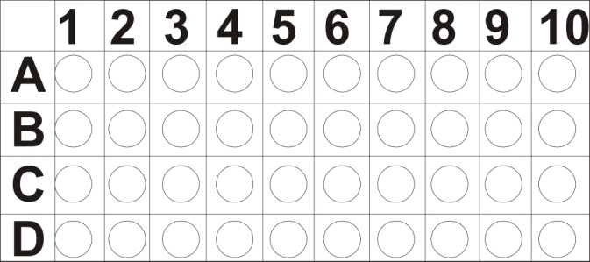

**SUBJECTIVE**

**Q2: Short Question** **(11 x 2 =22)**

1. What are the difference between the cell wall of plant and Fungal cell?
2. Write two functions of cytoplasm.
3. Differentiate b/w phagocytosis and endocytosis.
4. Define cytoskeleton. What are the main protein found in it?
5. Give silent features of cell theory.
6. Differentiate b/w RER and SER.
7. Write chemical composition of cell wall of plant cell.
8. What is polysome? Draw its diagram.
9. What are peroxisomes?
10. What are centrioles?
11. What is the contribution of Rudolf Virchow in cell biology?

**Q3: Long Question (8)**

1. What is plasma membrane? Explain its structure via Fluid mosaic model.
2. What are Lysosome? Explain its function with the reference to storage diseases.